Name: ___________________________________________

Lesson 5: Joins and Unions

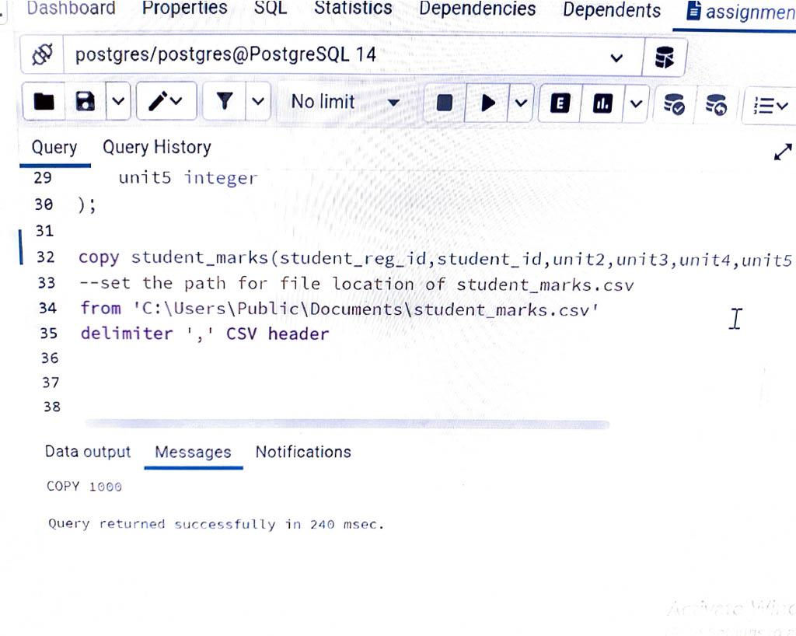

| 1. Create a table with the following parameters: |  |
| --- | --- |
|  | CustomerID |
|  | CustomerName |
|  | Address |
|  | City |
|  | PostalCode |
|  | Country |
|  | Email |
|  |  |
|  | CREATE TABLE A(customerid serial PRIMARY KEY, |
|  | CustomerName VARCHAR(255) NOT NULL, |
|  | Address VARCHAR(255) NOT NULL, |
|  | city VARCHAR(255), |
|  | postalcode VARCHAR(255) NOT NULL, |
|  | country VARCHAR(255) NOT NULL, |
|  | email VARCHAR(255)); |
|  |  |
|  |  |
|  |  |
|  | 2. Insert 3 rows of data into these columns using INSERT. The data you insert should make sense |
|  | for the column. |
|  |  |
|  | Insert into A |
|  | Values |
|  | ('Dave', 'Brand Rd', 'London', '123465','United Kingdom', 'dg@gamail.com'), |
|  | ('Dave', 'Brand Rd', 'London', '123465','United Kingdom', 'dg@gamail.com'), |
|  | ('Dave', 'Brand Rd', 'London', '123465','United Kingdom', 'dg@gamail.com'); |
|  |  |
|  |  |
|  | INSERT INTO table |
|  | SELECT column1, column2, |
|  | FROM another_table |
|  | WHERE condition; |
|  |  |
|  | INSERT INTO A |
|  | SELECT city |
|  | FROM account |
|  | WHERE |
|  |  |
|  | 3. Use an UPDATE to modify any portion of the data |
|  |  |
|  | UPDATE A |
|  | SET CITY = NEW YORK, EMAIL = GD@GAMIL.COM |
|  | WHERE CITY = LONDON; |
|  |  |
|  | 4. Finally, write a statement to delete one row of data. |
|  |  |
|  | DELETE FROM table_name WHERE condition; |
|  | DELETE FROMA WHERECITY = LONDON; |
|  |  |
|  | 1. Using the following Link |
|  | https://github.com/niteen11/cuny_lagcc_micro_credential_data_analytics/tree/main/Track%20A/U |
|  | nit%205%20-%20SQL_%20Relational%20Databases/guided%20exercise |
|  | First you have to create a table than upload the data ,safe the table in to your Laptop and change the |
|  | path accordingly.usr the following link for creating table, |
|  |  |
|  | https://github.com/niteen11/cuny_lagcc_micro_credential_data_analytics/blob/main/Track%20A/Unit |
|  | %205%20-%20SQL_%20Relational%20Databases/guided%20exercise/student.sql |
|  |  |
|  | And attached data set (Student_data and Student_marks ) answer the following questions : |
|  | -- students |
|  | with the |
|  | highest |
|  | marks in |
|  | Unit 4 |
|  |  |
|  | -- Find students scored between 89 and 100 unit4 |
|  |  |
|  | Open ended questions: |
|  | -- Take a closer look at the tables that you created and come up with 10 different scenarios/ |
|  |  |
|  | questions and form SQL |
|  | -- Ask your colleagues |